Sao Tome and Principe

## Political Stability Estimate Data

The data set shows the political stability estimate of the country each year.

## # A tibble: 19 x 5  
## country iso3c date stability stabilityCategory4  
## <chr> <chr> <dbl> <dbl> <chr>   
## 1 Sao Tome and Principe STP 1996 1.05 highly stable   
## 2 Sao Tome and Principe STP 1998 1.08 highly stable   
## 3 Sao Tome and Principe STP 2000 1.15 highly stable   
## 4 Sao Tome and Principe STP 2002 0.554 moderately stable   
## 5 Sao Tome and Principe STP 2003 0.260 moderately stable   
## 6 Sao Tome and Principe STP 2004 0.572 moderately stable   
## 7 Sao Tome and Principe STP 2005 0.576 moderately stable   
## 8 Sao Tome and Principe STP 2006 0.346 moderately stable   
## 9 Sao Tome and Principe STP 2007 0.394 moderately stable   
## 10 Sao Tome and Principe STP 2008 0.176 moderately stable   
## 11 Sao Tome and Principe STP 2009 0.146 moderately stable   
## 12 Sao Tome and Principe STP 2010 0.115 moderately stable   
## 13 Sao Tome and Principe STP 2011 0.00783 moderately stable   
## 14 Sao Tome and Principe STP 2012 0.0133 moderately stable   
## 15 Sao Tome and Principe STP 2013 0.112 moderately stable   
## 16 Sao Tome and Principe STP 2014 0.184 moderately stable   
## 17 Sao Tome and Principe STP 2015 0.144 moderately stable   
## 18 Sao Tome and Principe STP 2016 0.223 moderately stable   
## 19 Sao Tome and Principe STP 2017 0.215 moderately stable

## Political Stability Estimate Plot

The plot shows the trends of stabilization and destabilization for the each country.

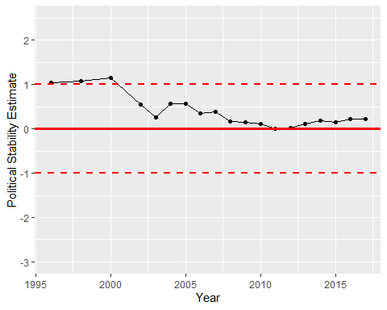

Political Stability Trend